**Mr. Visca’s: Calculus (Chpt 4.1)**

**Chpt 4 – Day 1: Applications of Derivatives**

**4.1 Applications of Derivatives**

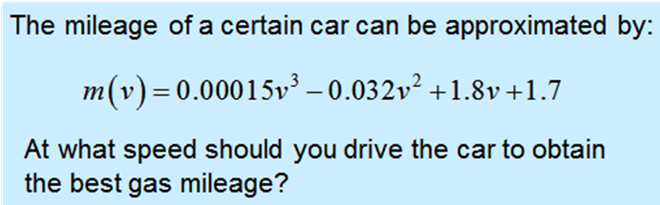

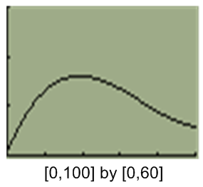

We could solve this problem graphically:

When you drive: _______________

Your gas mileage is: _____________

__________________________ are either maximum or minimum points on a curve.

They are sometimes called __________________ extremes.

They are also sometimes called absolute _________. (*__________* is the plural of the Latin *extremum*.)

Extreme values can be in the ________________ or the ________________ of a function.

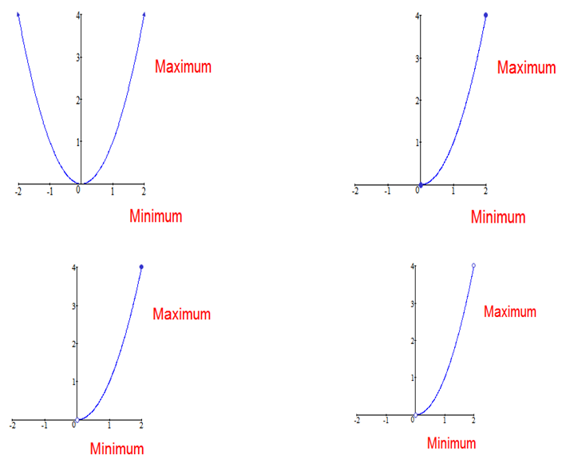



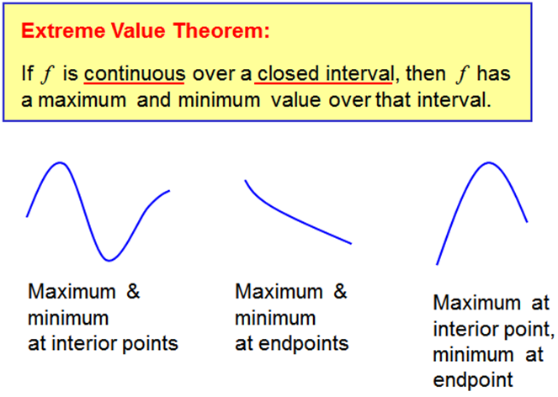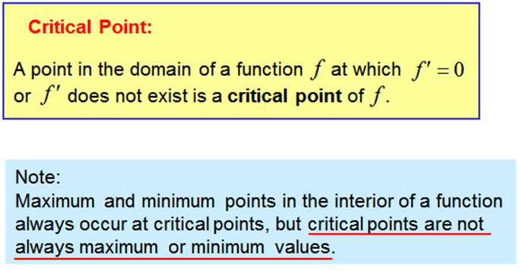

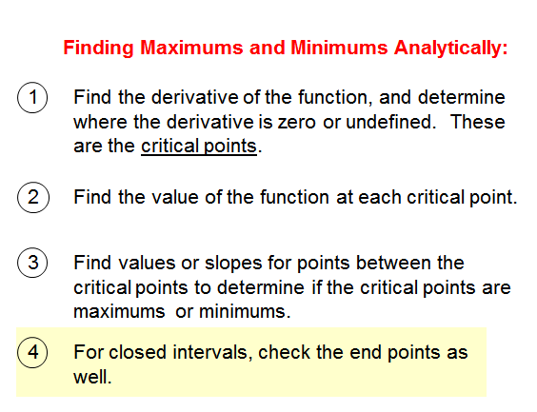

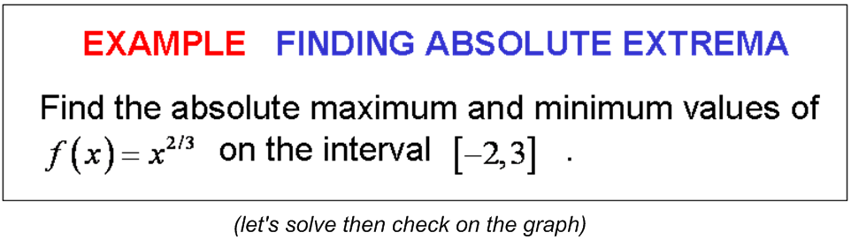

*Page 194 (5-12, 18, 19, 24, 43, 47, 48, 51)*

*Calculator allowed on all questions,*

*but extreme values need to be found analytically.*